**Phrase**

A phrase is a group of words that stands together as a single grammatical unit, typically as part of a clause or a sentence.  
  
A phrase does not contain a [subject](https://www.grammar-monster.com/glossary/subject.htm) and [verb](https://www.grammar-monster.com/lessons/verbs.htm) and, consequently, cannot convey a complete thought. A phrase contrasts with a [clause](https://www.grammar-monster.com/glossary/clause.htm). A clause does contain a subject and verb, and it can convey a complete idea.

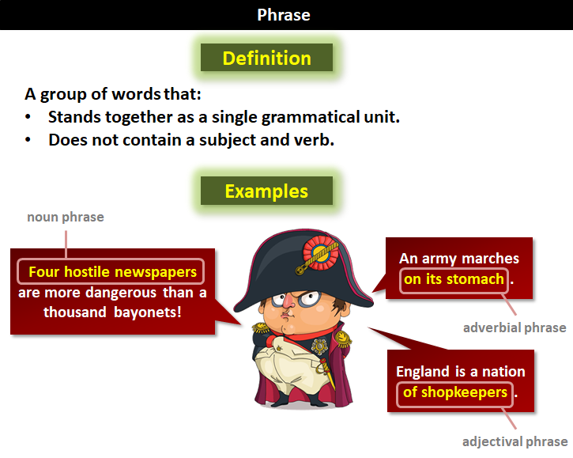

**Easy Examples of Phrases**

Let's start with a sentence that has no phrases and then build some in.

* Janet eats cakes daily.

(This sentence has no phrases. All of the parts of the sentence are single words.)

* My cousin Janet eats cakes daily.

(Now we have a phrase. It's a three-word phrase functioning as the subject of this sentence. Note that the phrase itself does not contain its own subject and verb.)

* My cousin Janet eats cakes during the week.

(We've added another phrase. This one also has three words, but it is functioning as an [adverb](https://www.grammar-monster.com/lessons/adverbs.htm).)

* My cousin Janet was eating cakes during the week.

(We've added another phrase. This one has two words. It is a multi-word [verb](https://www.grammar-monster.com/lessons/verbs.htm).)

* My cousin Janet was eating cream cakes from the bakery during the week.

(We've added another phrase. This one has five words. It is functioning as a [direct object](https://www.grammar-monster.com/glossary/direct_object.htm) in this sentence.)

The examples above prove that phrases function as one single unit within a sentence. But, let's look a little closer.  
  
The term "cream cakes from the bakery" has its own embedded phrase ("from the bakery"). This is a [prepositional phrase](https://www.grammar-monster.com/glossary/prepositional_phrase.htm) describing the "cream cakes." So, it's possible to have a phrase within a phrase. It's common in fact. There's more. The words "was eating cream cakes from the bakery during the week" is also classified a phrase. It's called a verb phrase. (A verb phrase consists of a verb and all its modifiers. Those modifiers could also be phrases, as they are in this example.)

**Common Types of Phrase**

Here are some examples of the common types of phrase.

**Adjective Phrase**

An adjective phrase is a group of words headed by an adjective that modifies a noun. In these examples, the adjective phrases are shaded and the head adjective is in bold.

* Dexter had noticeably **evil** eyes.

(Here, the adjective phrase modifies "Dexter.")

* Victoria was immensely **proud** of us.

(Here, the adjective phrase modifies "Victoria.")

The term "adjectival phrase" is often used interchangeably with "adjective phrase," but many grammarians reserve "adjectival phrase" for multi-word adjectives that are not headed by an adjective. For example:

* My auntie is the lady with all the unicorn tattoos.

(The phrase "with all the unicorn tattoos" is a multi-word adjective describing "the lady," but it is not headed by an adjective (hence no word in bold). Headed by the preposition "with," this is an example of a prepositional phrase functioning as an adjective. It is best classified as an adjectival phrase as opposed to an adjective phrase.)

**Adverbial Phrase**

An adverbial phrase is a group of words that functions as an adverb. In these examples, the adverbial phrases are shaded.

* He sings in a low register.

(Here, "in a low register" modifies the verb "sings." As it is headed by the [preposition](https://www.grammar-monster.com/lessons/prepositions.htm) "in," this adverbial phrase is also a prepositional phrase.)

* Luckily for us, we arrived just in time.

(Here, the adverbial phrase modifies the verb "arrived.")

**Noun Phrase**

A noun phrase consists of a noun and all its modifiers. In these examples, the noun phrases are shaded and the head nouns are in bold.

* How much is that **doggy** in the window?

(Here, the head noun is "doggy." "That" is a modifier. "In the window" is also a modifier (a [prepositional phrase](https://www.grammar-monster.com/glossary/prepositional_phrase.htm) functioning as an adjective describing "doggy.")

* You can tell a lot about a fellow's character by his **way** of eating jellybeans.

(Here, the modifier "of eating jellybeans" is a [prepositional phrase](https://www.grammar-monster.com/glossary/prepositional_phrase.htm) functioning as an adjective describing "way." The prepositional phrase itself contains the [gerund phrase](https://www.grammar-monster.com/glossary/gerund_phrase.htm) (see below) "eating jellybeans." So this simple noun phrase has an embedded phrase that itself has an embedded phrase. As you can see, the term "phrase" has a broad scope. Remember that a phrase is any group of words that function as a single unit.)

**Prepositional Phrase**

A prepositional phrase is a group of words that consists of a preposition, its object (which will be a noun or a pronoun), and any words that modify the object. In these examples, the prepositional phrases are shaded and the prepositions are in bold.

* I lived **near** the beach.

(As is the case here, a prepositional phrase can stand alone as a single unit within a sentence. Here, the prepositional phrase is an [adverb of place](https://www.grammar-monster.com/lessons/adverbs.htm).)

* How much is that doggy **in** the window?

(Quite often, a prepositional phrase features in another phrase. Remember this example from above? Here, the prepositional phrase is functioning as an adjective describing "doggy." It is part of the noun phrase "that doggy in the window.")

* You can tell a lot about a fellow's character **by** his way of eating jellybeans.

(Remember this example from above? Here, the prepositional phrase is functioning as an adverb modifying "can tell." Notice that the highlighted prepositional phrase includes another prepositional phrase ("of eating jellybeans"). Yeah, it can get complicated.)

**Gerund Phrase**

A gerund phrase is a phrase that consists of a gerund, its object, and any modifiers. In these examples, the gerund phrases are shaded and the [gerunds](https://www.grammar-monster.com/glossary/gerunds.htm) are in bold.

* **Moving** quickly but stealthily is the key to survival.
* Arithmetic is the ability to count up to twenty without **taking** off your shoes. (Mickey Mouse)

**Infinitive Phrase**

An infinitive phrase is the infinitive form of a verb plus any complements and modifiers. In these examples, the infinitive phrases are shaded and the [infinitive verbs](https://www.grammar-monster.com/glossary/gerunds.htm) are in bold.

* She tells you **to dance** like no one is watching.
* The first step in forgiveness is the willingness **to forgive** those who have wronged us.